**COMSATS University Islamabad, Lahore Campus**

**CSC-495 Game Development**

**Assignment 2: Lab 13-14 TO DO List**

**Submission Deadline: Friday 1 pm, 29th October 2021**

**Task 1**

1. Add Terrain, Night lights and FPS Controller in a scene, just like in lab 11-12
2. Add Medieval Cartoon Warrior pack from asset store as asked in Lab 11-12
3. Drag Male-A character from character🡪Male folder of that pack
4. Increase size of Male-A, rotate it
5. Place Male-A exactly at the enemy position and make it child of enemy as shown below

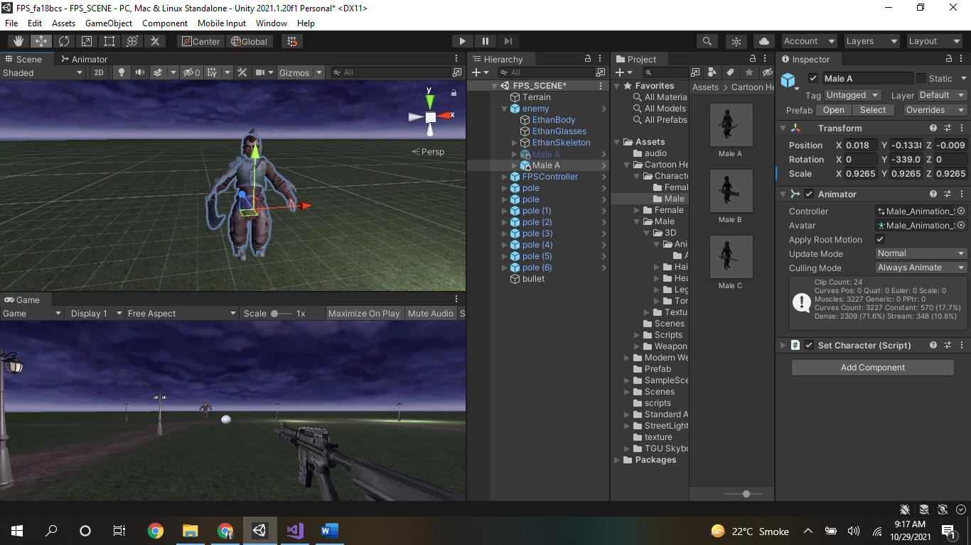

1. Play the game, you will notice Male-A will be dragged with the enemy towards the FPS Controller
2. In Animator component of the enemy, change its Avatar (below controller to Male Animation Skeleton Avatar)
3. Play game again, now you will notice Male-A will properly run (animated towards the FPSController)
4. Bring back Male-A to the main hierarchy, i.e. it should be not be the child of enemy now.
5. Disable enemy from the game and rename MaleA as MaleEnemy.

Task 2

1. Open the Animator of MaleEnemy
2. Click its controller, which will open the Male_Animation_Skeleton Animator just with the game scene as shown below:

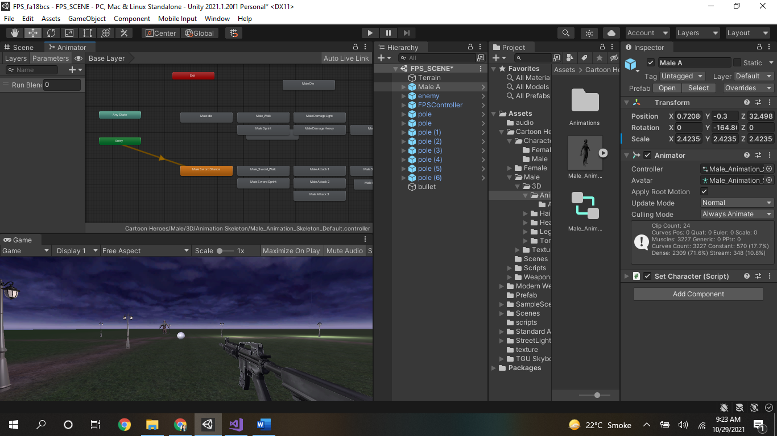

1. You will see different animations states, green state will be entry state and orange state will be default state (Male sword stance). There will also be a transition (arrow) between entry and default state.
2. Now find two states: 1- “Male_Walk”, 2- Male_Die

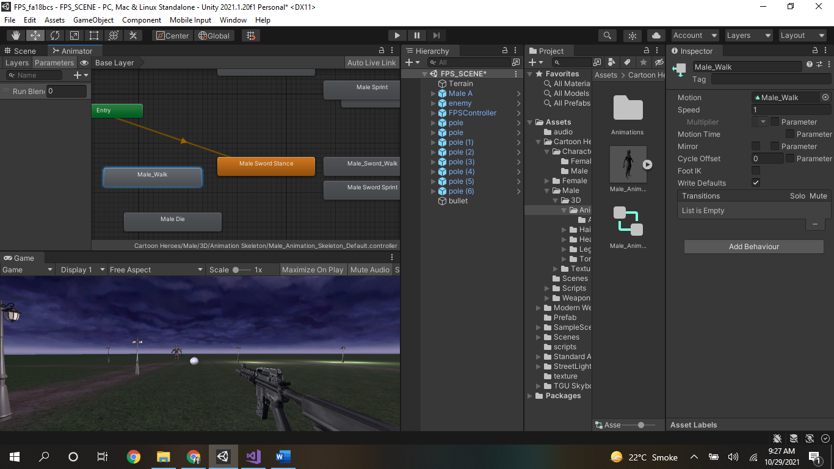

1. Make two way transitions between them with default state by right clicking🡪make transition option

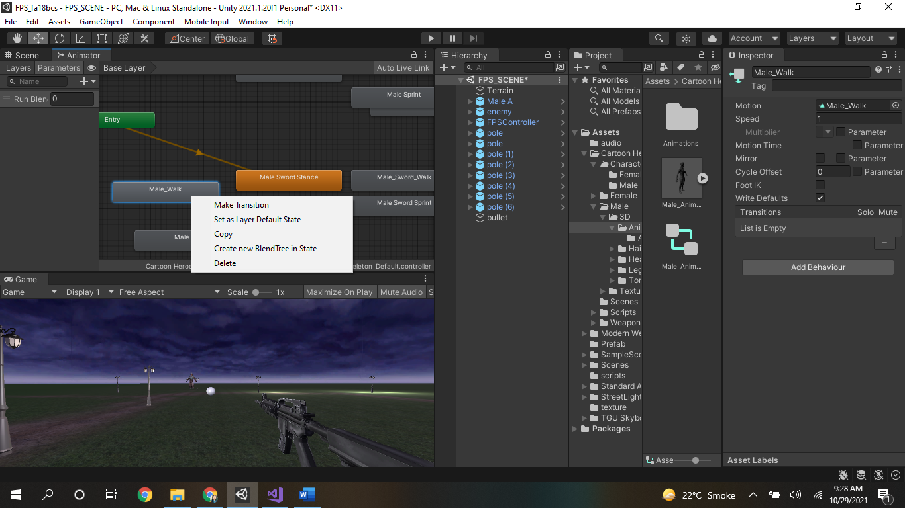

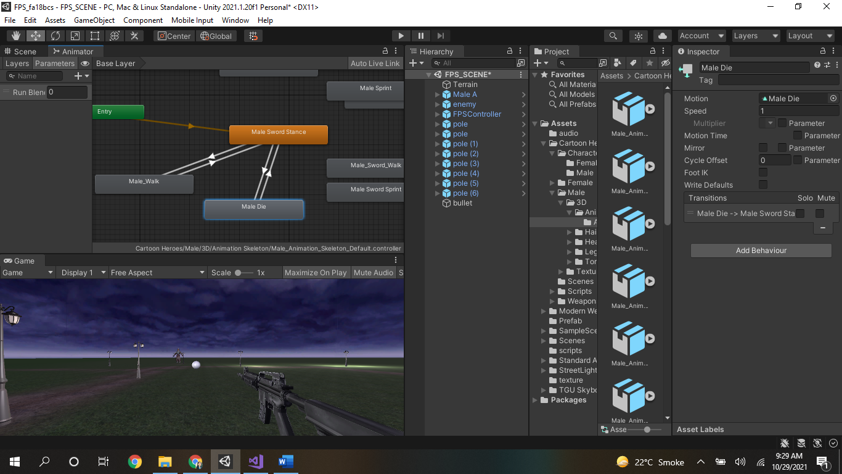

1. Add bool parameters isWalk and isDead from right top tab of parameter
2. Enable isWalk and isDead parameters

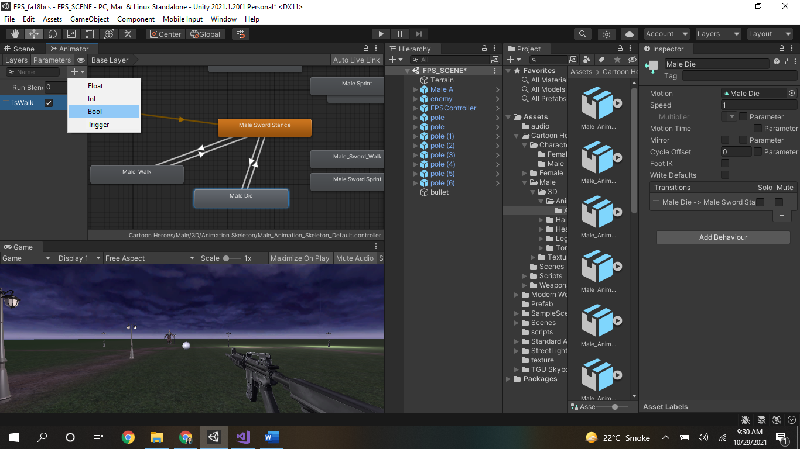

1. Click on transitions going from Male_Walk and Male_Die to default and add conditions isWalk and isDead as true, respectively.

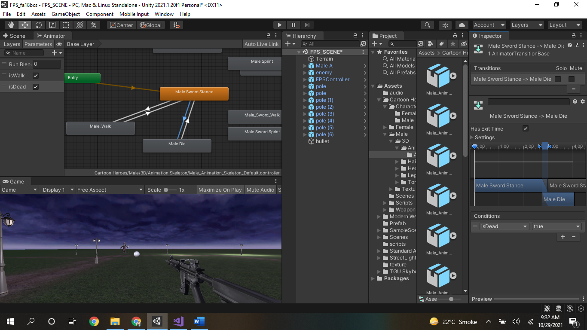

1. Click on transitions going from default to Male_Walk and Male_Die and add conditions isWalk and isDead as false, respectively.
2. Now your animator has been updated and you want MaleEnemy to walk when played and dead when bullet collides with it.
3. For that purpose, add box collider at MaleEnemy and make collider y size = 3.5
4. Add EnemyDie.cs script to MaleEnemy

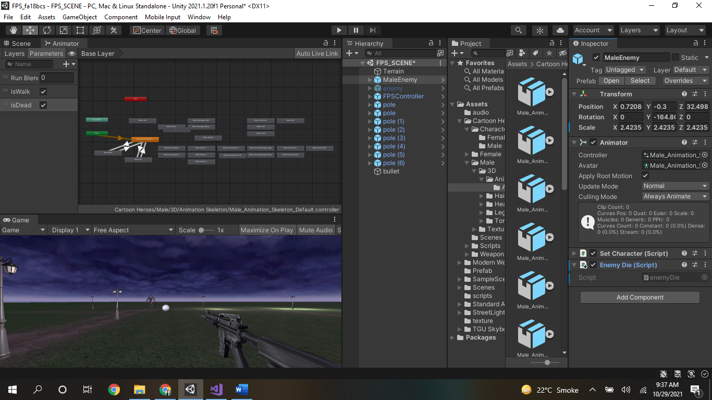

1. Make enemy translate towards the FPS by LookAt method
2. Instantiate the enemies (put 3 enemies and instantiate its 5 copies)
3. On every dying enemy, increase score to +5
4. When Enemy reaches FPS, load Gameover Scene

enemyDie.cs Script:

using System.Collections;

using System.Collections.Generic;

using UnityEngine;

public class enemyDie : MonoBehaviour

{

Animator myAnimator;

// Start is called before the first frame update

void Start()

{

myAnimator = GetComponent<Animator>();

myAnimator.SetBool("isWalk", true);

myAnimator.SetBool("isDead", false);

}

// Update is called once per frame

void Update()

{

}

private void OnCollisionEnter(Collision collision)

{

if (collision.transform)

{

print("enemy hit");

myAnimator.SetBool("isWalk", false);

myAnimator.SetBool("isDead", true);

}

Destroy(collision.gameObject);

}

}

Other scripts used in project (done some changes):

BulletController.cs:

using System.Collections;

using System.Collections.Generic;

using UnityEngine;

public class BulletLanucher : MonoBehaviour

{

public GameObject bullet;

// Start is called before the first frame update

void Start()

{

}

// Update is called once per frame

void Update()

{

if(Input.GetMouseButtonDown(0))

{

Instantiate(bullet, transform.position, transform.rotation);

}

}

}

BulletScript.cs:

using System.Collections;

using System.Collections.Generic;

using UnityEngine;

public class bulletScript : MonoBehaviour

{

// Start is called before the first frame update

void Start()

{

}

// Update is called once per frame

void Update()

{

//transform.Translate(0, 0, 1);

Rigidbody r = GetComponent<Rigidbody>();

r.AddForce(transform.forward *100);

}

}

**Task 3**

Add character from mixamo.com and replace it MaleEnemy and try same animation on that character. Make sure to extract textures of that character by clicking its prefab and making rig humanoid.

_____________________________________END__________________________________